THE SACRAMENT OF PENANCE

AND RECONCILIATION
FOR SCHOOL-AGED CANDIDATES
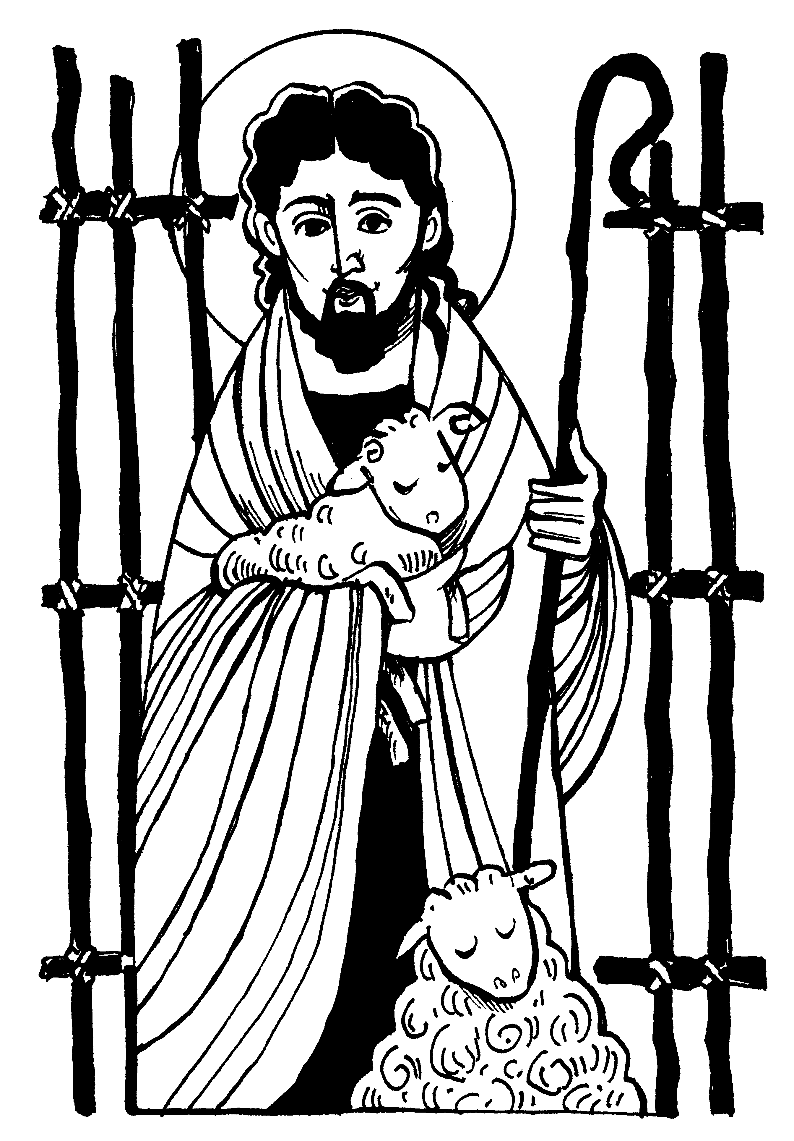

THE PARISH OF

OUR LADY OF GOOD COUNSEL

A MESSAGE FROM OUR PARISH PRIESTS

Dear Parents and Guardians:

May the peace and love of Our Lady of Good Counsel be with you.

Since its earliest days, the Church has recognized parents as the first educators of the faith. It is within the “domestic Church” created by each Christian family that baptized children first learn about God’s love for them. Little by little, they are taught to love God through simple prayer and good deeds. Within the family atmosphere, young consciences are formed and develop as they begin to recognize good and bad choices, and how these choices help or hurt their relationship with God and God’s people.

Your children are now of catechetical age. Their faith formation takes on more formal tones as they have been enrolled in a religious education program in our Parish. Although the practice and living of the Catholic faith is still the primary obligation of the parent, the School and PREP aid our parish families in the religious training of our Parish children. Now the religion lessons of the home are further developed intellectually and intuitively on an age-appropriate level.

As priests, we are commissioned by the Church to identify the goals and needs for our religious education program, and to also oversee the catechetical and sacramental preparation of our parish children. We take this ministry seriously.

This year is a very important time in your child’s faith life as he/she prepares to meet Jesus in a new way in the Sacrament of Penance. In addition to classroom instruction, a parish sacramental program that includes parent meetings, activities, prayer services, and information packages has been structured to enhance parental involvement in this sacramental preparation. We urge you to take advantage of these opportunities. Also, take advantage of this special time to tell your child the stories about your own reception of the sacraments and about other personal faith moments. Pray daily at meal times and before bedtime. Talk to him or her about his/her guardian angel or about our Catholic saints. Most importantly, on Sundays, assist with your child at the Holy Sacrifice of the Mass, the central mystery and belief of the Catholic sacramental life. May your child’s entry into the Church be your stepping-stone to Christ.

On March 18 and March 25, 2021 our parish school-aged candidates will be invited to encounter Christ in the Sacrament of Penance for the first time. This special moment of grace harkens back to the promises of Baptism that made them children of God and recipients of God’s unconditional love. This sacrament opens them to God’s Holy Spirit and a Christian vision for a lifetime. As the parish anticipates this great moment of joy for your child, please be assured of my continued prayers for all involved in the sacramental preparation of your child. May Our Lady of Good Counsel bless all our endeavors.

Wishing God’s blessing on you and your family.

Devotedly,
Reverend Robert Suskey

Reverend Msgr. Joseph A. Tracy

Reverend John Kilgallon (Ret., In Res.)

SACRAMENT OF PENANCE AND RECONCILIATION*
(Source is The Catechism of the Catholic Church)

“You were washed, you were sanctified, you were justified in the name of the Lord, Jesus Christ and in the Spirit of God.” (1 Corinthians 6:11)

In the Sacrament of Baptism, the gift of new life as a child of God and the promise for eternal life is given. Nevertheless, the magnitude of this sacrament of initiation does not remove the attraction of human nature to sin. The life of a baptized Catholic, therefore, is a continual journey of one’s spirit turning towards God and away from the temptations of this world that rupture our relationship with God and the Church. This is the struggle of conversion to Christ, holiness, and eternal life.

“If we say we have no sin, we deceive ourselves, and the truth is not in us.” (1 John1:8)

At times, however, the believer fails to follow the Gospel message of Jesus Christ by giving into these temptations. Theologically these actions are called sins. Sins that involve a serious or grave matter and are a total and deliberate turning away from God and rejection of the Church are called mortal sins. Everyday faults that do not remove us from communion with God and the Church are called venial.

“On the evening of that day, the first day of the week” Jesus showed himself to the Apostles and “breathed the Holy Spirit on them, and said to them: ’Receive the Holy Spirit. If you forgive the sins of any, they are forgiven; if your retain the sins of any, they are retained.’ (John 20:19, 22-23)

Only God can forgive sins.
The Sacrament of Penance and Reconciliation is the Church’s liturgical prayer that reconciles a believer who has sinned with God*. In this sacrament, the sinner admits to Christ, in the person of the priest, his/her offense to the Christian life while expressing a sincere contrition and willingness to make satisfaction for this sin. Within the loving and merciful embrace of God’s Holy Spirit, the sinner is pardoned by the priest and returned to a life of grace. Thus, the Sacrament of Penance and Reconciliation restores the baptismal relationship between Father and child and continues the interior conversion of the believer.

Mortal sins must be confessed to a priest in the Sacrament of Penance. It is not strictly necessary but is strongly encouraged by the Church to confess venial sins to a priest in the Sacrament of Penance. Regular confession of venial sins helps a believer to form his/her conscience in order to recognize and avoid these temptations while being healed through the saving love of Jesus Christ.

THE RELIGION CORE CURRICULUM FOR YEARS ONE AND TWO

The following beliefs of the Catholic faith are taught on a level that is psychologically and educationally appropriate for a primary school aged child. These guidelines have been developed and approved by the Archdiocese of Philadelphia in answer to the Church’s call to promote the faith through religious education. Please refer to your child’s religion textbook for specific information.

YEAR ONE
The Trinity— God, the Father and Creator (and how we live in the world);
God, the Son and our Savior of the World, Jesus Christ;
God, the Holy Spirit, who lives in us and gives us grace through
the Sacraments of Initiation

The Church and the Liturgical Seasons
Mary—her feast days and special prayers and devotions
Prayers –Sign of the Cross, Our Father, Hail Mary, Doxology (Glory be)

YEAR TWO
BUILD ON YEAR ONE’S CONCEPTS AND INTRODUCES:

The Seven Sacraments (Initiation, Healing, & at the service of communion)
The Mass and its parts
The Mass and the Eucharist—praise, thanks, grace and community
Sacred vestments and vessels used at Mass
Sacramentals of the Church
Act of Contrition

CATECHESIS FOR THE RECEPTION OF 1ST PENANCE AND RECONCILIATION

“Catechesis for children must always respect the natural disposition, ability, age, and circumstances of individuals. It seeks, first, to make clear the relationship of the sacrament to the child’s life; second, to help the child to recognize moral good and evil, repent for wrongdoing, and turn for forgiveness to Christ and the Church; third, to encourage the child to see that, in this sacrament, faith is expressed by being forgiven and forgiving; fourth, to encourage the child to approach the sacrament freely and regularly.”

National Catechetical Directory, Article #126

The theme of the Good Shepherd is used throughout this sacramental preparation.
--Relationship with God (the Good Shepherd)
--Moral sense of good (grace/community) and evil (sin/breakdown of relationship)
--Types of sin (mortal & venial)
--Examination of Conscience (enclosed)
--The Rite of Penance and Reconciliation (enclosed)
--The Act of Contrition (enclosed)

How can a parent help with the sacramental preparation for First Penance and Reconciliation?

Repetition is the mother of all learning. This is especially true of a primary school age child when looking forward to a big life event. This notion also carries over to sacramental preparation with young children.

The Church has always maintained that a consistent and loving witness to one’s faith by a parent teaches more than any classroom lesson to a child. Parents, therefore, should be mindful of the child’s prayer life, in particular, worshipping at Mass on Sundays and Holy Days of Obligation and saying daily prayers. In addition, parents should teach the child about the Catholic faith and support your child’s catechist by reviewing all classroom work and assignments at home.

Since sacramental preparation asks for the mastery of new concepts and prayers, some additional suggestions for this year follow:

- Help your child become acquainted with the Rite of Penance by role- playing the Rite of Penance with your child often.
- At bedtime or another convenient time read and discuss the story of the Good Shepherd.
- Pray the questions of the Examination of Conscience while your child answers privately in his/her heart to God.
- As a response to this examination say the Act of Contrition with your child, end with the Prayer of Absolution from the Rite of Penance.
- Write a “Message of Love” and give to your child either before or after his/her reception of the sacrament.

Finally, if you sense that your child is not ready for this sacrament please discuss this situation with your child’s catechist.

Timeline for the Sacrament of Reconciliation and Penance

The Sacrament of First Penance and Reconciliation will be
celebrated at Our Lady of Good Counsel Church
on Thursday evening, March 18, 2021 at 7:00 PM.
(Classes: Mrs. McMenamin & Mrs. Gross)
AND on Thursday, March 25, 2021 at 7:00PM
(Classes: Ms. Borio)
Families, please be in the Upper Church at 6:45pm

IMPORTANT DATES

Completed information sheet in sacrament packet is due to the PREP office no later than November 6, 2020.

Sacrament packet available for printing on October 1, 2020 on the parish website:
www.olgc.org
- Click on “Parish”
- Click on “Sacraments”
- Click on “”Sacraments of Healing”
- Click on “Reconciliation (Penance)”

Mandatory Sacrament Talk for 1st Time Parents Wednesday, November 11, 2020
(McNelis Room Trinity Center) 6:00pm-7:00pm

This is a mandatory presentation for all parents of sacrament children. Non-attendance will result in attendance at a faith formation session (in February).

EXAMINATION OF CONSCIENCE

CARING FOR GOD

Do I listen and talk with God?
Do I praise God and visit Him on His Holy Day?
Do I thank God for all He has given me?
Do I tell God I am sorry when I am selfish?

CARING FOR OTHERS

Do I obey my parents and others who care for me?
Am I kind to others and respectful towards them?
Do I help others?
Do I forgive people who hurt me?
Do I tell the truth?
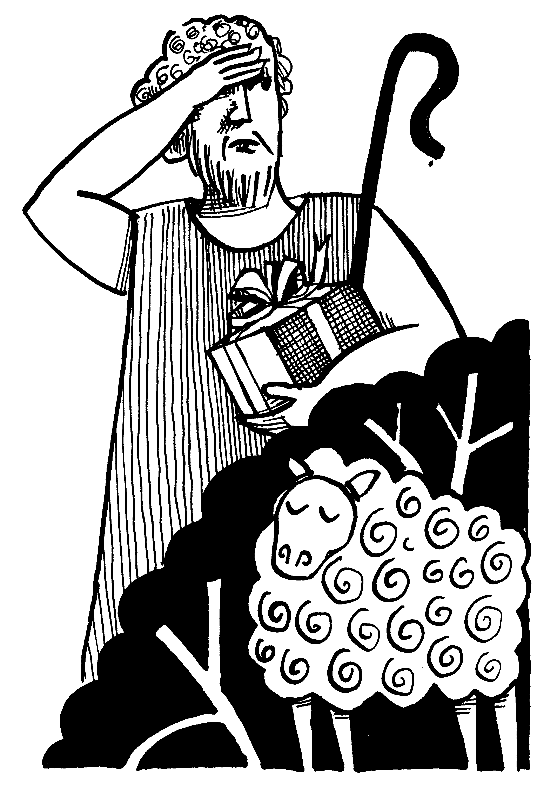
CARING FOR MYSELF AND GOD'S WORLD

Do I take care of my body?
Do I take care of what I have?
Am I wasteful?
Do I share my things?
Do I treat animals with care?

RITE FOR RECONCILIATION OF INDIVIDUAL PENITENTS

Penitents may choose to receive the Sacrament of Penance and Reconciliation either “face to face” or anonymously.
RECEPTION OF THE PENITENT
The priest welcomes the penitent.
The penitent: IN THE NAME OF THE FATHER, AND THE SON, AND THE HOLY SPIRIT.
AMEN.
The priest invites the penitent to have trust in God.

READING OF THE WORD OF GOD (OPTIONAL)
The priest or penitent may read a text of Holy Scripture.

CONFESSION OF SINS AND ACCEPTANCE OF SATISFACTION

The penitent: (BLESS ME, FATHER, FOR I HAVE SINNED.)

THIS IS MY FIRST CONFESSION.

THESE ARE MY SINS:

Tell the priest your sins with honesty and sorrow, and also
tell the priest a little about yourself.

The priest will listen to you and guide you.

The penitent: I AM SORRY FOR THESE AND ALL MY SINS.

The priest will give you a penance to help make up for your sins and to change your heart.

PRAYER OF THE PENITENT AND ABSOLUTION
(Act of Contrition—next page)

After the Act of Contrition, the priest will give you Absolution.

At the end of the Absolution, make the sign of
the cross and say, AMEN.

PROCLAMATION OF PRAISE AND DISMISSAL

The priest: Give thanks to the Lord, for he is good.
The penitent: HIS MERCY ENDURES FOREVER.

The priest dismisses the penitent in peace.
The penitent then leaves and says his/her prayers of penance.

Act of Contrition

O MY GOD

I AM VERY SORRY

FOR HAVING OFFENDED YOU,

AND I DETEST ALL MY SINS

BECAUSE OF YOUR JUST PUNISHMENTS,

BUT MOST OF ALL

BECAUSE THEY OFFEND YOU, MY GOD,

WHO ARE ALL GOOD

AND DESERVING OF ALL MY LOVE.

I FIRMLY RESOLVE,

WITH THE HELP OF YOUR GRACE,

TO SIN NO MORE

AND TO AVOID THE NEAR OCCASIONS OF SIN.

AMEN.

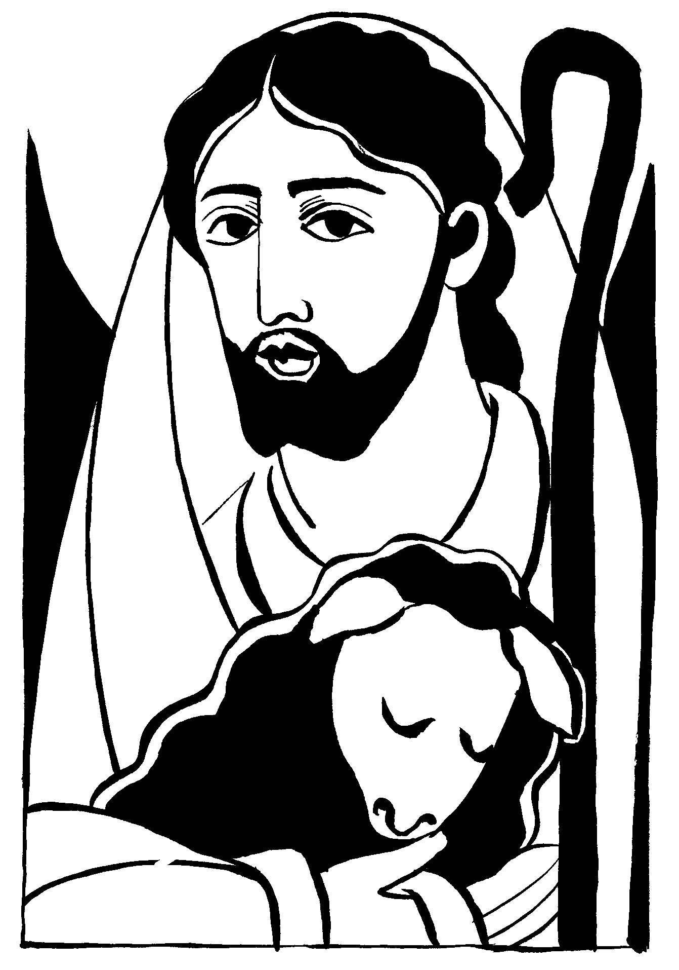

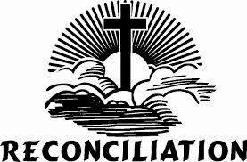
1st Penance & Reconciliation

OUR LADY OF GOOD COUNSEL PARISH

INFORMATION FORM FOR THE SACRAMENT OF INITIATION, PENANCE AND RECONCILIATION

Please print or type information! Thank you!

PREP ______ School ______ Teacher’s Name: ________________________________

Candidate's Full Name __________________________________________________________
(Last) (First) (Middle)

Address _____________________________________________________________________
(Street)

_____________________________________________________________________
(Town) (State) (Zip)

Candidate's Date of Birth ________________________________________________________
(Month) (Day) (Year)

Candidate's Place of Birth ________________________________________________________
(Town) (State)

Candidate's Date of Baptism ______________________________________________________
(Month) (Day) (Year)

Candidate's Church of Baptism* ____________________________________________________
(Name of Church)

____________________________________________________
(Street Address)

____________________________________________________
(Town) (State) (Zip)

Father's Name _________________________________________________________________
(Last) (First) (Middle)

Mother's Name ________________________________________________________________
(Last) (First) (Maiden)

Godfather's Name ______________________________________________________________
(Last) (First) (Middle)

Godmother's Name _____________________________________________________________
(Last) (First) (Middle)

*It is not the policy of OLGC School or PREP to retain an original copy of your child’s Baptismal certificate, Therefore, please attach a copy of your child's Baptismal Certificate to this form. Thank you!

PLEASE RETURN THIS FORM IN AN ENVELOPE MARKED: Our Lady of Good Counsel Parish Office Attn: Kristal Alexander 215-357-1300, ext. 134 Due by November 6, 2020

